**Cryptography And System Security**

**Experiment No. : 01**

**Aim : Design and Implementation of Caesar Cipher.**

**Program :**

#include<stdio.h>

#include<string.h>

#include<conio.h>

#include<ctype.h>

void main()

{

    char plain[10],cipher[10];

    int key,i,length;

    int result;

    printf("\n Enter the plain text:");

    scanf("%s",plain);

    printf("\n Enter the key value:");

    scanf("%d",&key);

    printf("\n\n\t PLAIN TEXt:%s",plain);

    printf("\n\n\t ENCRYPTED TEXT:");

    for(i=0,length=strlen(plain);i<length;i++)

    {

        cipher[i]=plain[i]+key;

        if(isupper(plain[i])&&(cipher[i]>'z'))

        cipher[i]=cipher[i]-26;

        if(islower(plain[i])&&(cipher[i]>'z'))

        cipher[i]=cipher[i]-26;

        printf("%c",cipher[i]);

    }

    printf("\n\n\t AFTER DECRYPTION :");

    for(i=0;i<length;i++)

    {

        plain[i]=cipher[i]-key;

    if(isupper(cipher[i])&&(plain[i]<'A'))

    plain[i]=plain[i]+26;

    if(islower(cipher[i])&&(plain[i]<'a'))

    plain[i]=plain[i]+26;

    printf("%c",plain[i]);

    }

    getch();

}

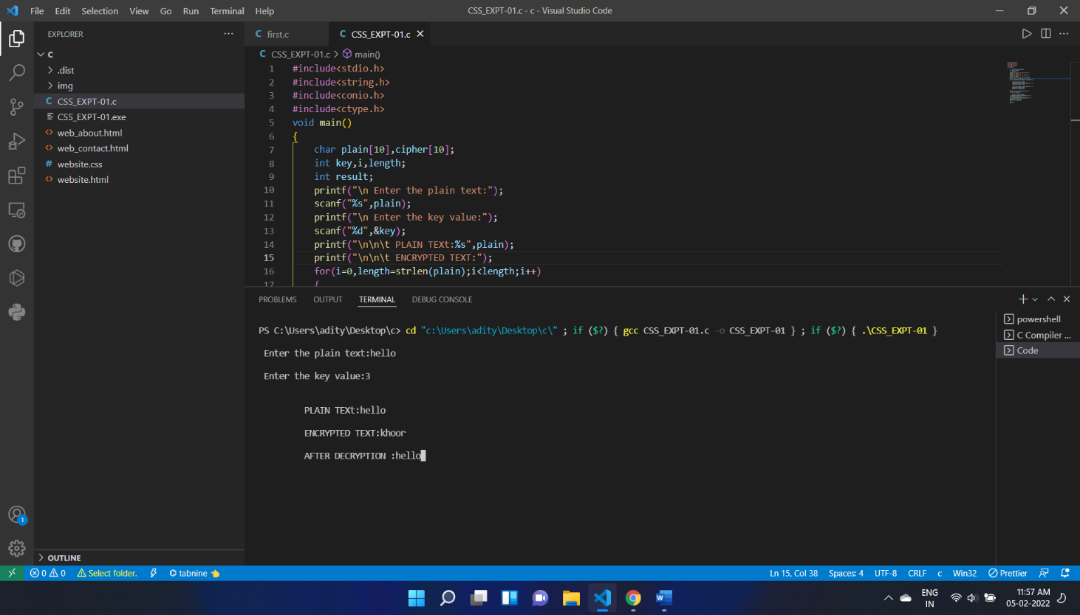**Output :**